**HARDWARE COMPONENTS**

1. **Ultrasonic Sensor :**

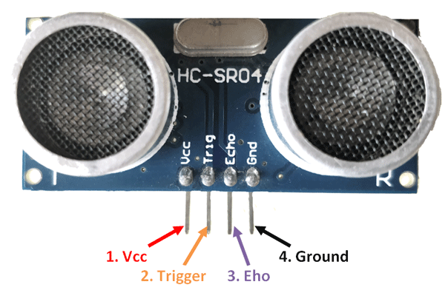

Product name **:** HCSR04

Range : 2cm – 400 cm

Max range : 4m

Measuring angle : 15 degree

Working Voltage : 5v

Working current : 15mA

Working frequency: 40Hz

Trigger I/P signal : 10us TTL pulse